Deliverable 3 – Legendary Team
Written by: Stefan Ikonomovski

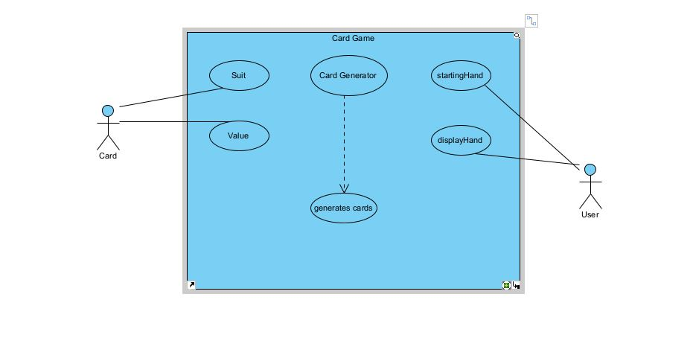

This is the use case diagram for the Card Game. Suit and Value depend on Card. CardGenerator generates random values of cards. For example: HEART, DIAMOND, SPADE, CLUB and ACE, TWO, THREE, FOUR, FIVE, SIX, SEVEN, EIGHT, NINE, TEN, JACK, QUEEN, KING, etc. User starts hand and displays hand.

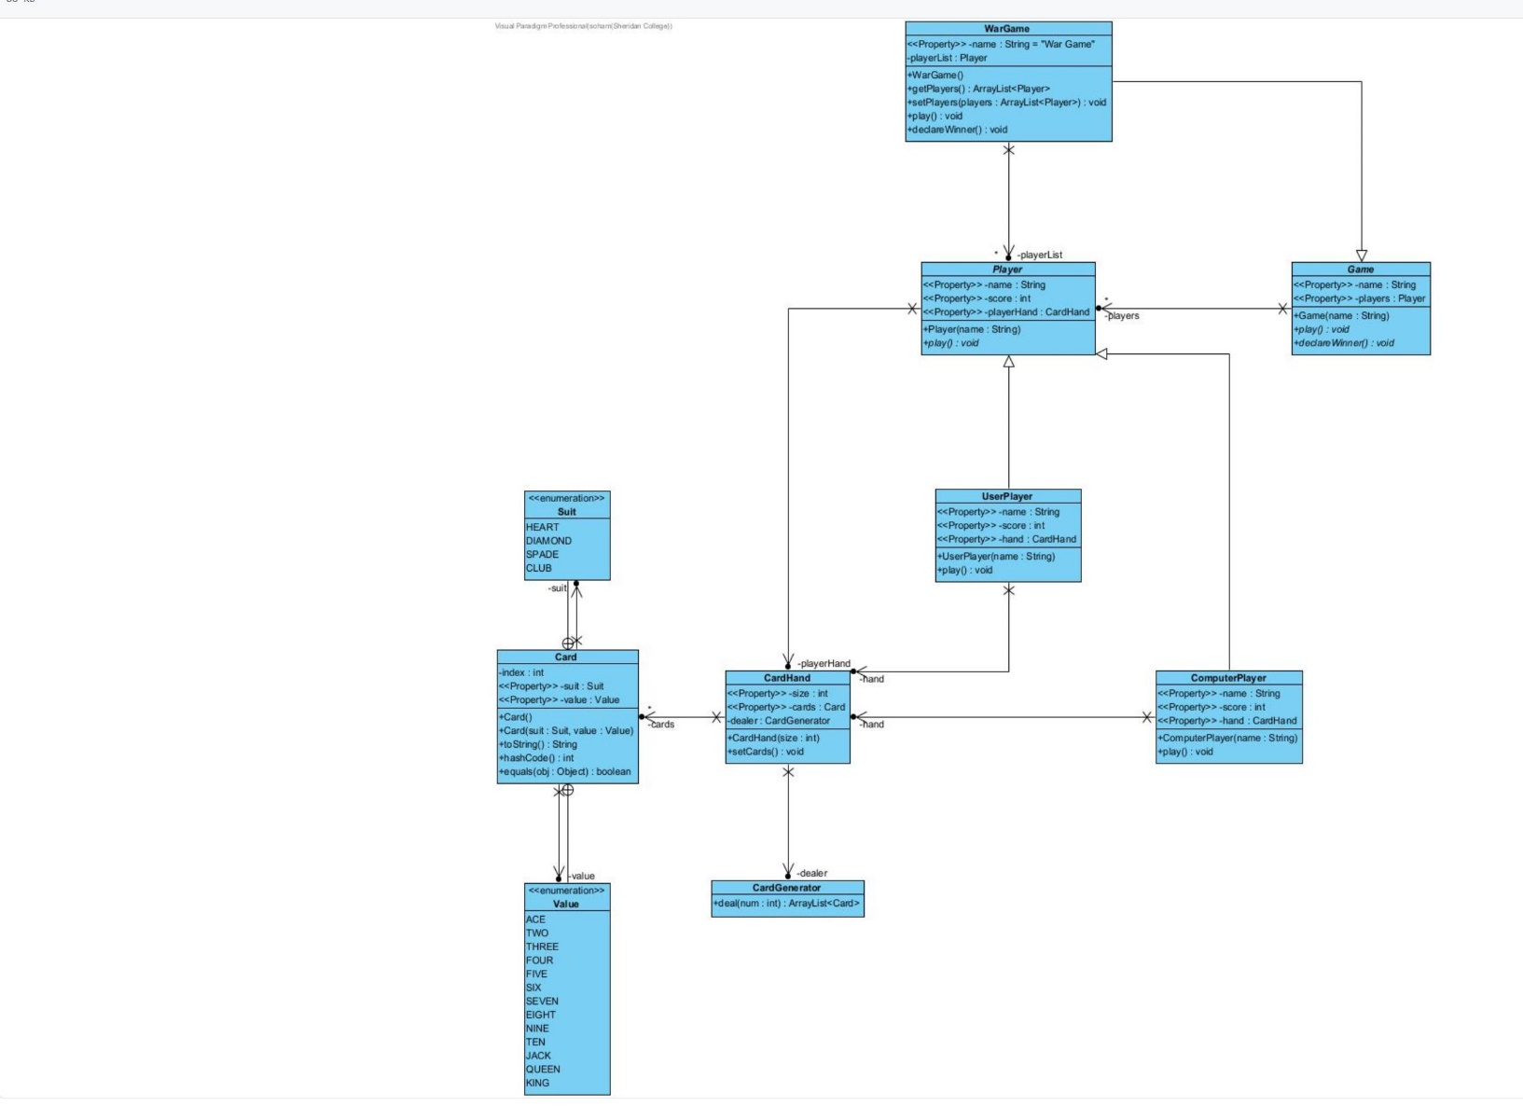
This is the UML diagram for the War Game. First it starts with the Card class by putting the Suits and Values outcomes. Card suits the Suit enumerations and values the Value enumerations. CardHand hands the Card and deals with the CardGenerator. CardGenerator generates a random number of cards. It starts from 0 and then it moves forward. CardHand class has the variables size (which is final), cards with ArrayList, and dealer which is also final with the CardGenerator class. If the cards are empty they will be removed. ComputerPlayer class extends the Player class. The ComputerPlayer variable is set to public with String name and name is declared with super. At the end it overrides play and has a print statement. Game class has the String variable name and the player Player variable. It has the declareWinner method to determine how many points will the winner have. Player class has the variables name, score, and playerHand and they are all protected. The score starts from 0 as always. UserPlayer has the variables name, score, and hand. UserPlayer extends Player class. The UserPlayer class is declared with String name. The name is declared with super. There is an override method and there is a print statement saying the name of the player plays what. WarGame has the variables name with the “War Game” quotations and Player. It has a print statement with “Starting the War Game”. First if card 1 is greater than card 2 then 0+ points are added. If card 2 is greater than card 1 then 1+ points are added else it would be a tie. Start class starts with a main method as always. It starts with the WarGame variable, ArrayList<Player>, adds players, sets players, and plays the game.
Use Case Narration
1. Primary Actor User Starts Game (Main method)
2. Secondary Actor WarGame, instantiates 2 players Computer and Player1
3. WarGame makes 26 cards and assigns them to Player1
4. WarGame makes 26 cards and assigns them to Computer
5. User is Prompted to play a card
6. User Chooses one card to Play
7. Seconary Actor Computer Randomly Picks one card
5.1 Card Values are equal
5.1.1 No points awarded
5.2 Player Card is Higher
5.2.1 Player 1 receives 1 point
5.3 Computer Card is Higher
5.2.2 Computer receives 1 point
6. Repeat 4-5 until all cards are exhausted
7. WarGame checks Both Player Scores
7.1 Player1 score is Higher
7.1.1 Display Message “Player1 Wins”
7.2 Computer score is Higher
7.2.1 Display Message “Computer Wins”
7.3 Scores are Equal

